1. Resolve Merge Conflicts
Goal
Fix conflicts when Git cannot automatically merge changes.
Steps
- Create a repo and clone it
- git clone <repo-url>
- cd repo

Create a branch
git checkout -b feature1
Edit the same file and commit
echo "Hello from feature1" > file.txt
git add file.txt
git commit -m "feature1 change"
Switch to main and edit the same line
git checkout main
echo "Hello from main" > file.txt
git add file.txt
git commit -m "main change"
Merge branch
git merge feature1
Resolve conflict manually in file
Mark resolved and commit
git add file.txt
git commit -m "Resolved merge conflict"
Create a Merge Conflict Intentionally
Goal
Simulate two users editing the same line.
Steps
- User A edits line 1 and commits
- User B edits the same line and commits
- Merge → conflict occurs
(This is automatically achieved using Step 1)
Resolve Conflict and Push Change
git push origin main

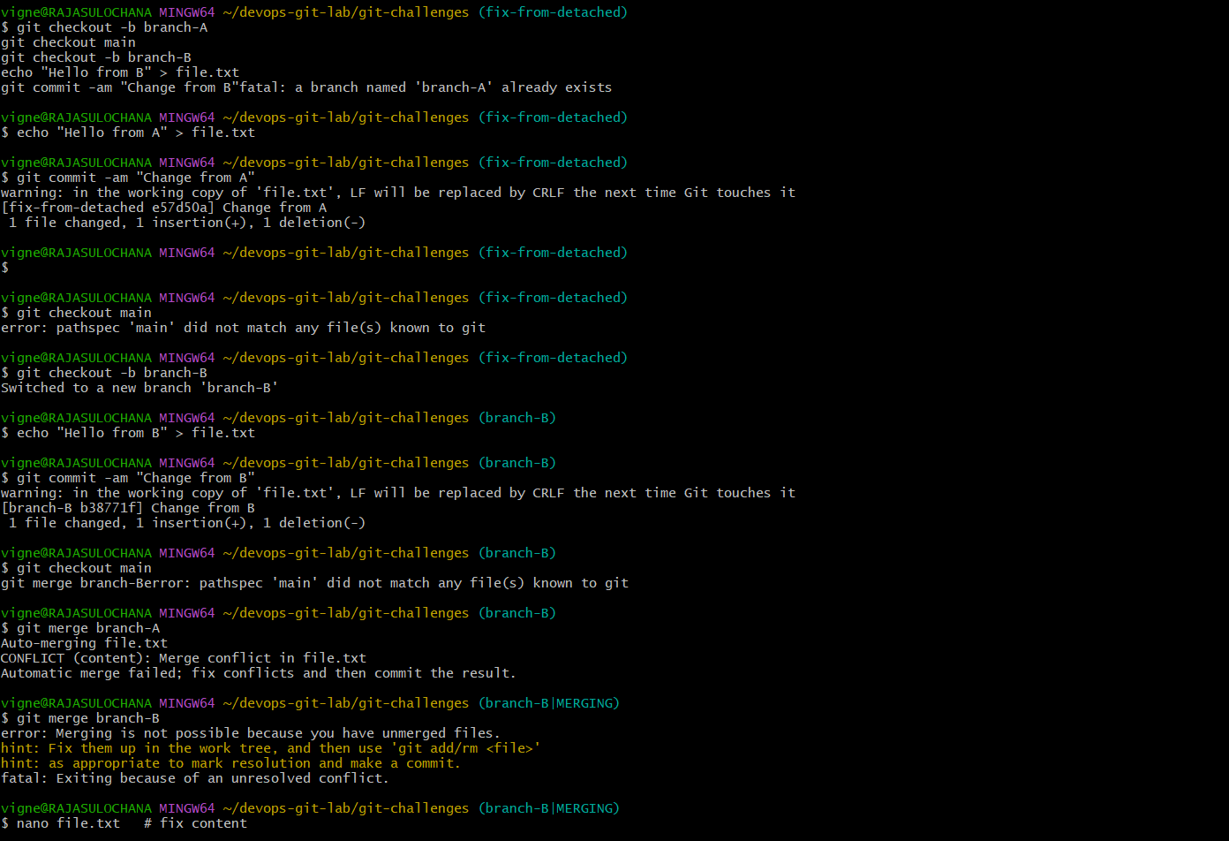
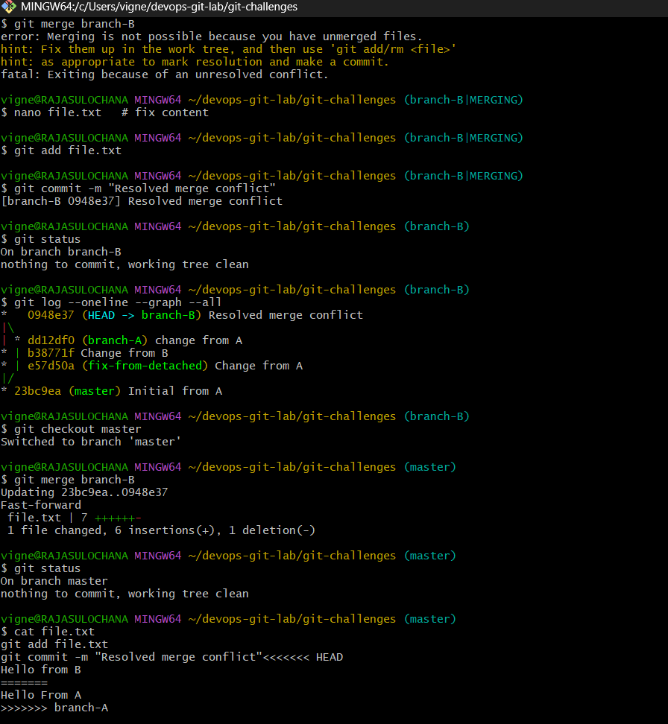

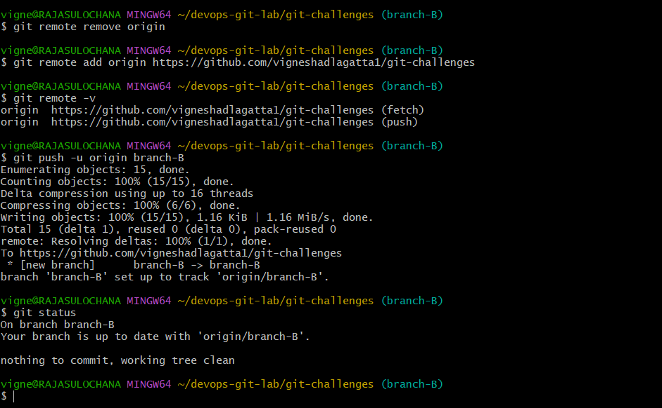

2 Recover Deleted Branch
git branch -d feature1
Recover using reflog
git reflog
git checkout -b feature1 <commit-hash>
Delete Local Branch and Recover Using Reflog
git branch -D test-branch
git reflog
git checkout -b test-branch <hash>

3) Undo Wrong Push
Undo a pushed commit without losing history.
Push Wrong Commit and Undo (Safe Way)
git revert <commit-id>
git push origin mainPush Wrong Commit and Undo (Safe Way)

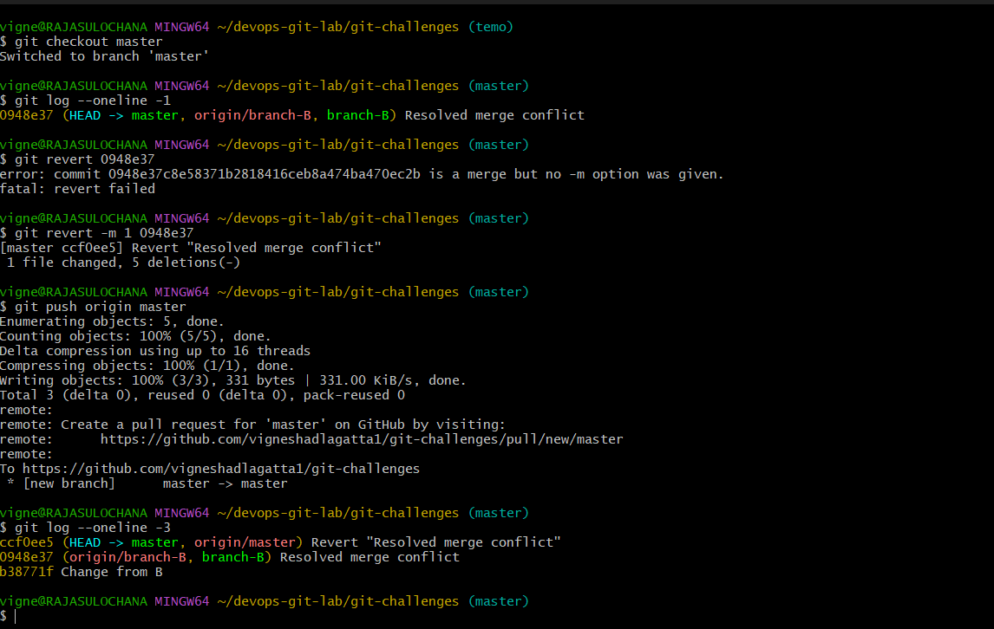
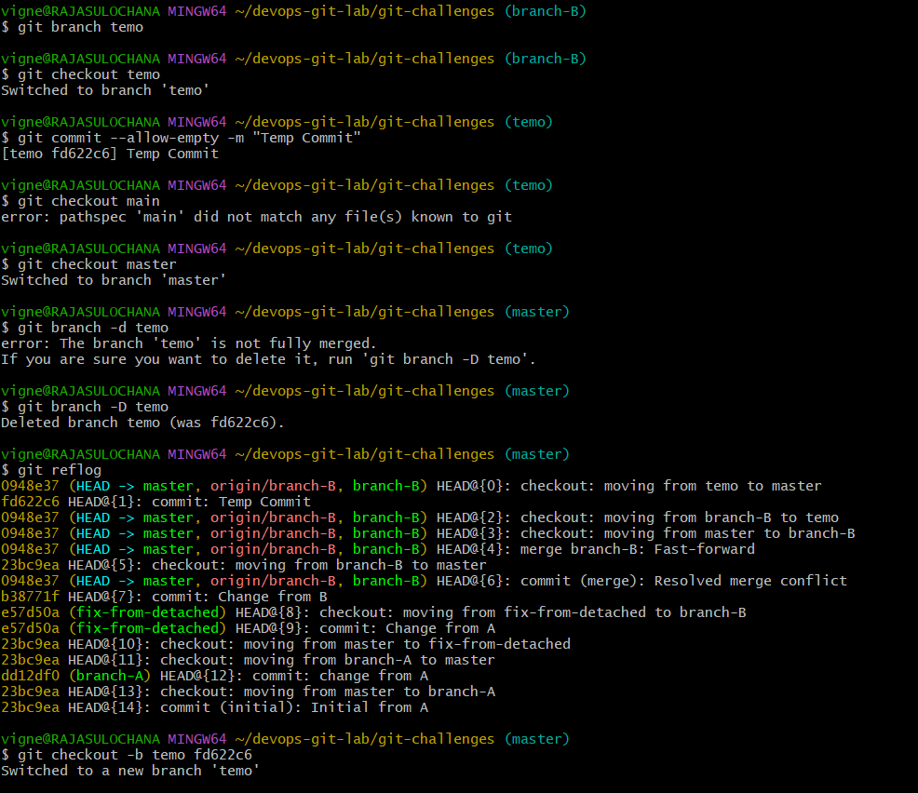

4) Amend Last Commit
git add missing_file.txt
git commit --amend

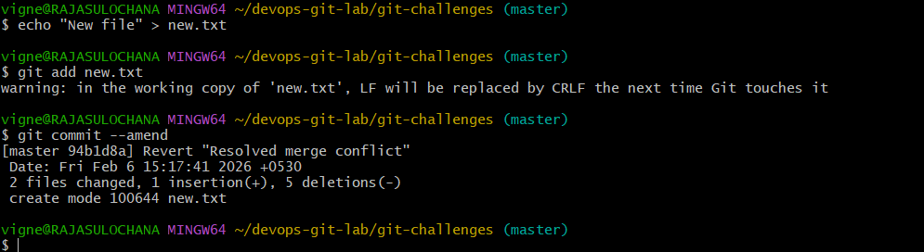

5) Cherry-pick a Commit
git checkout target-branch
git cherry-pick <commit-hash>
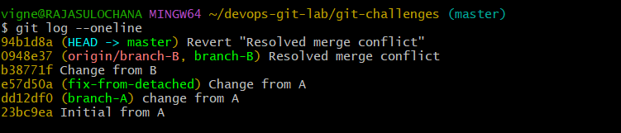

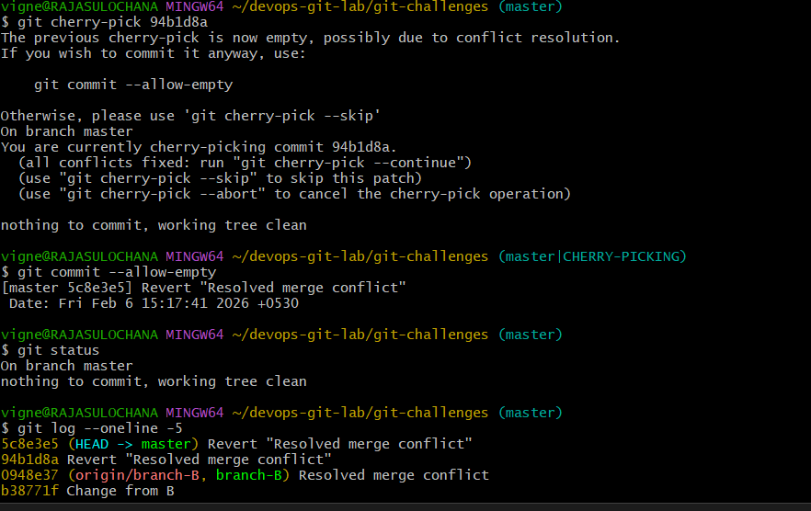
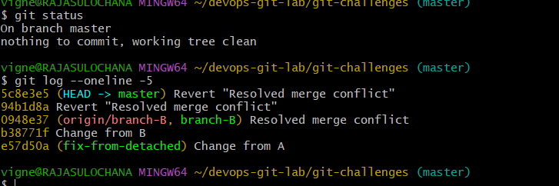

6) Interactive Rebase
git rebase -i HEAD~3
pick → keep
squash → combine
reorder commits
Reorder & Squash Commits
Inside rebase editor:
pick a1 commit1
squash b2 commit2
squash c3 commit3

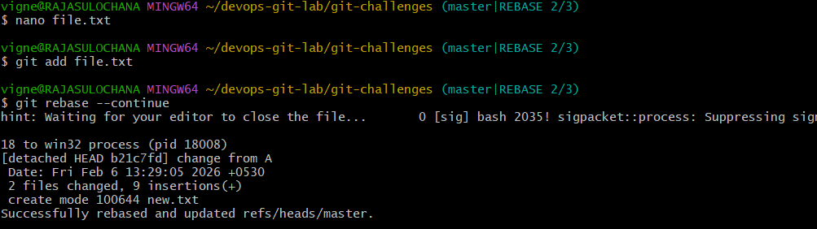
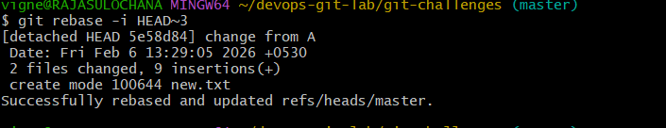

7) Tagging & Release
Create Tag v1.0
git tag v1.0
git push origin v1.0
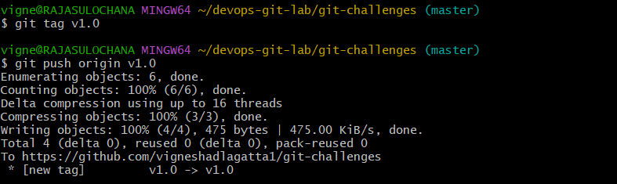
Delete & Restore Tag
git tag -d v1.0
git push origin --delete v1.0
git tag v1.0 <commit>

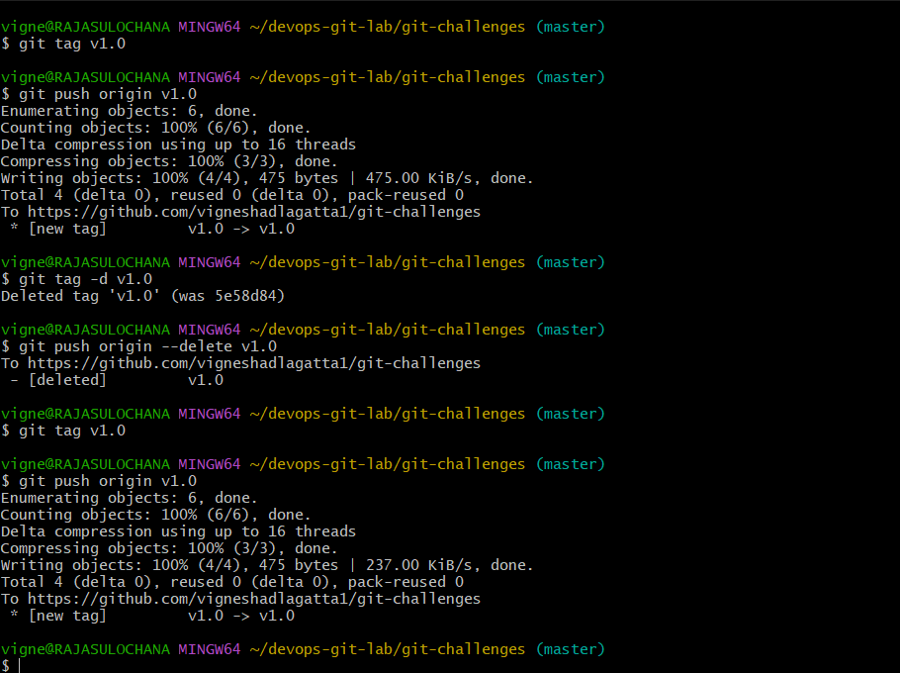

8) Clone with Sparse Checkout
git clone --no-checkout <repo>
cd repo
git sparse-checkout init --cone
git sparse-checkout set folder-name
git checkout
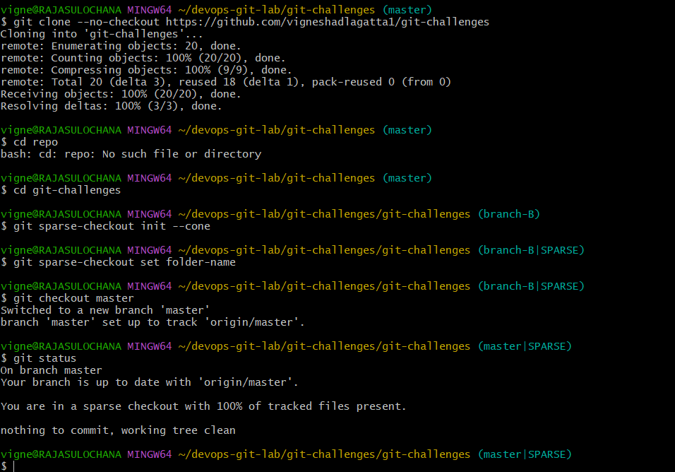

9) Clone Only Subdirectory
(Same as above – sparse checkout)
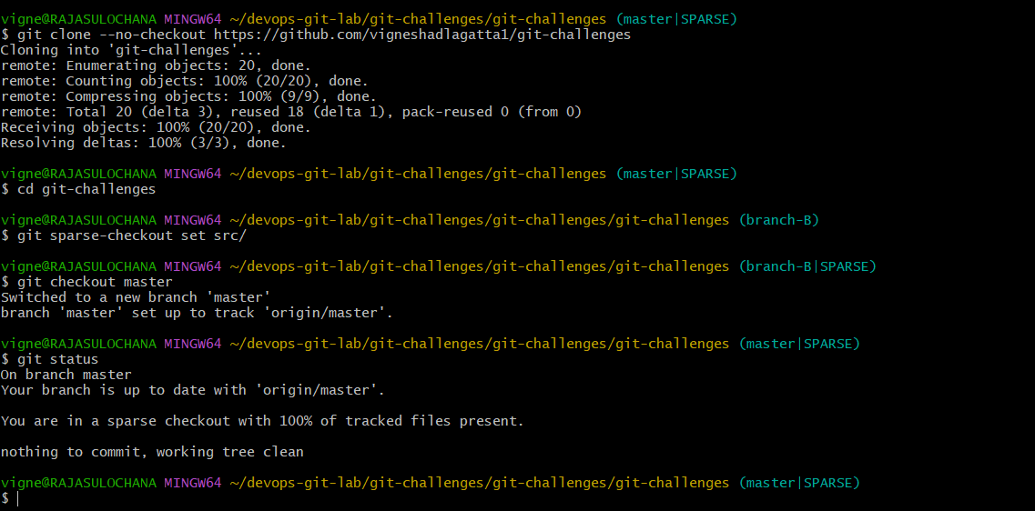
10) Reset vs Revert Challenge
git reset –hard
git reset --hard HEAD~1
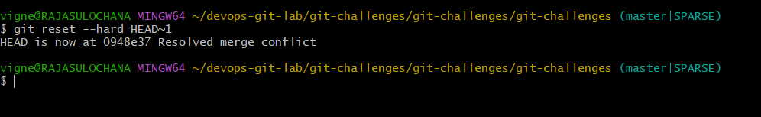

git revert
git revert HEAD
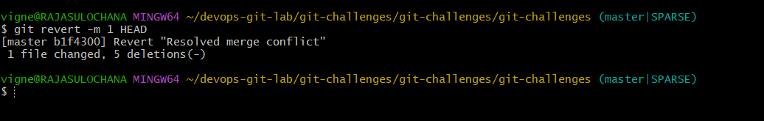

11) Detached HEAD Challenge
git checkout <commit-id>
Create branch from detached HEAD:
git checkout -b new-branch
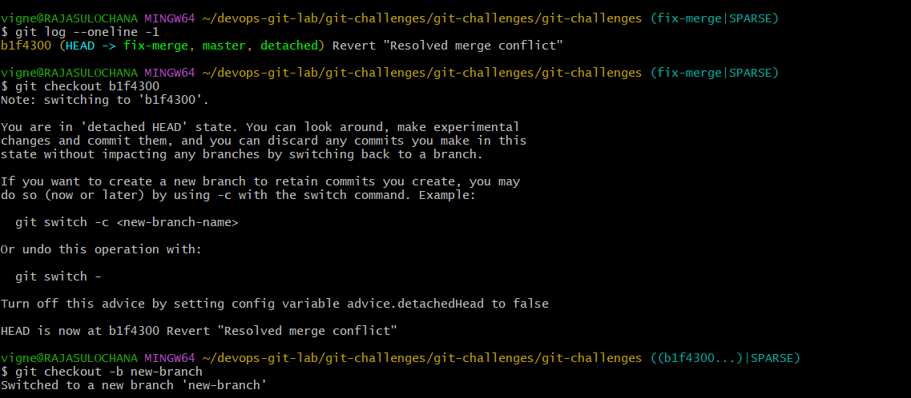

12) Git Hooks Challenge
cd .git/hooks
nano pre-commit
#!/bin/bash
msg=$(cat .git/COMMIT_EDITMSG)
if [[ ! $msg =~ ^JIRA-[0-9]+ ]]; then
echo "Commit message must start with JIRA-XXX"
exit 1
fi
chmod +x pre-commit

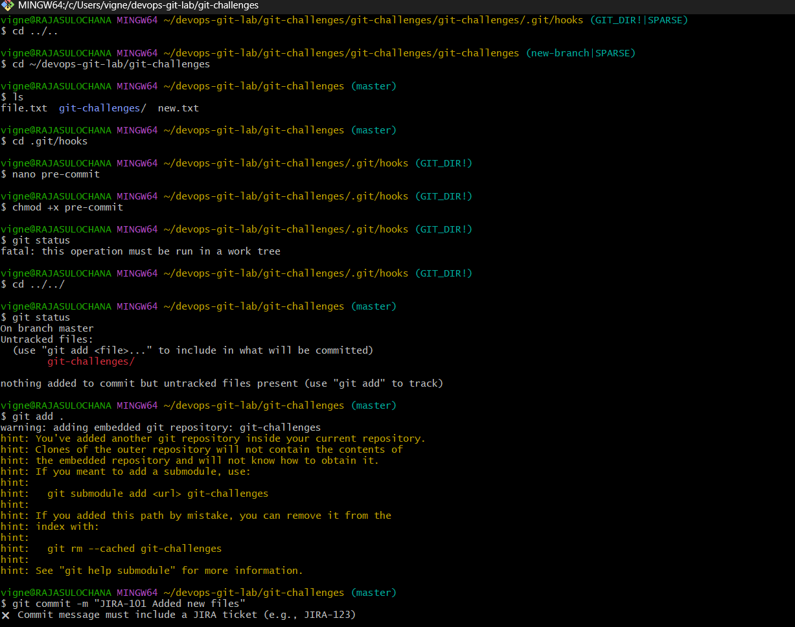

13) Squash Merge vs Rebase Merge
Squash Merge
- One commit
- Clean history
What it does
- Takes multiple commits from a feature branch
- Combines (squashes) them into ONE single commit
- Then merges into target branch
Pros
- Clean, linear history
- One commit per feature
- Easy to revert
- Perfect for messy WIP commits

Cons
- Individual commit history is lost
- No trace of small steps
When to use
- Feature branches
- Many “fix typo”, “oops”, “try again” commits
- Teams that want clean main branch
Rebase Merge
- Linear history
- Rewrites commits
What it does
- Rewrites commit history
- Moves feature branch commits on top of main
- Keeps each commit separate
Pros
- Linear history
- Keeps full commit details
- Easy to debug with git bisect
Cons
- Rewrites history (dangerous on shared branches)
- Conflicts can be painful
- Not safe after pushing
When to use
- Small, clean commits
- Solo branches
- When commit history matters

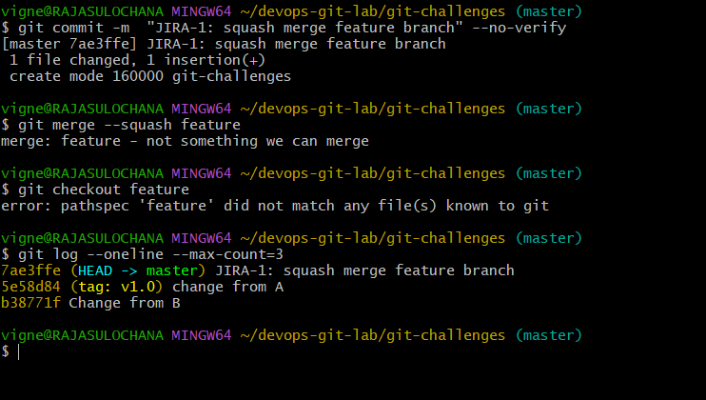

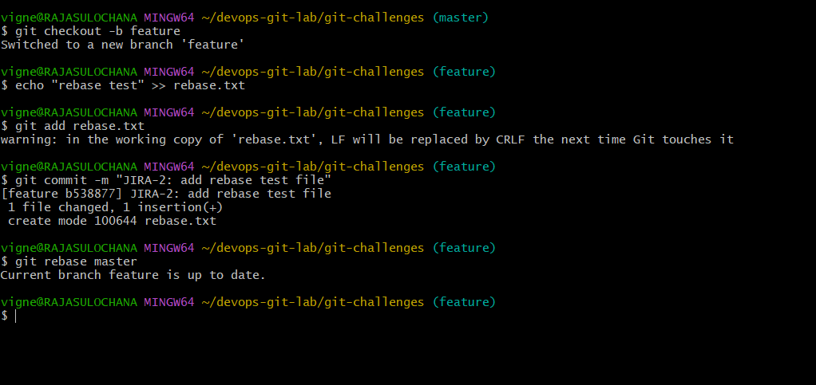
14) Fork & Pull Request Workflow
• Fork repo on GitHub
• Clone fork
git clone <fork-url>
• Create branch
• Push changes
git push origin branch-name
• Open Pull Request
Fork&PullRequestWorkflow(Short&Sweet)

1.Fork(GitHub)

ForktheoriginalrepositorytoyourGitHubaccount.

2.CloneYourFork

gitclonehttps://github.com/YOUR_USERNAME/repo.git
cdrepo

3.AddUpstream(OriginalRepo)

gitremoteaddupstreamhttps://github.com/ORIGINAL_OWNER/repo.git
gitremote-v

4.CreateFeatureBranch

gitcheckout-bfeature/my-change

5.MakeChanges&Commit

gitadd.
gitcommit-m"JIRA-123Description"

6.PushtoYourFork

gitpushoriginfeature/my-change

7.CreatePullRequest(GitHub)

Compyourbranchwithoriginalrepo→CreatePR.

8.SyncFork(BestPractice)

gitcheckoutmain
gitfetchupstream
gitmergeupstream/main
gitpushoriginmain

Flow

Fork→Clone→Branch→Commit→Push→PullRequest

---

UseForkwhenyoudon’thavewriteaccess.PRisusedtoproposechangestotheoriginalrepo.
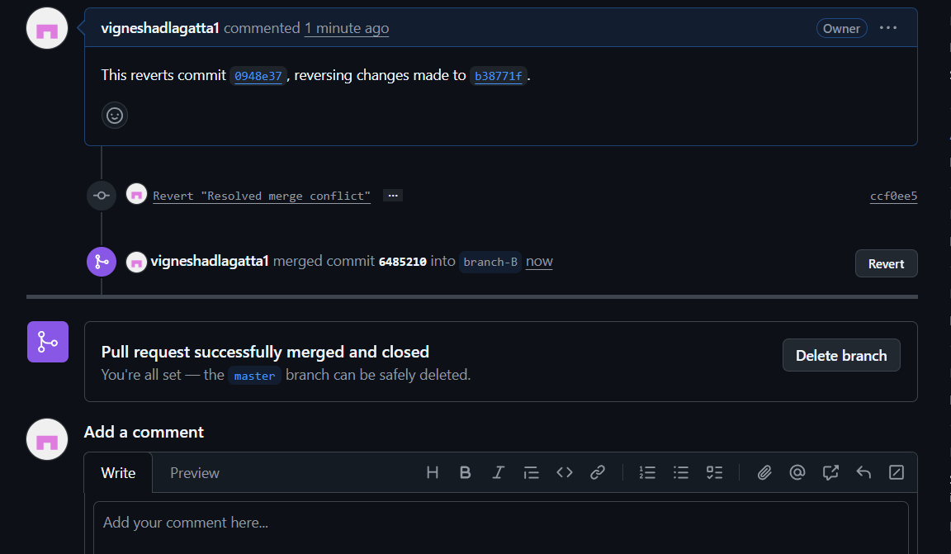
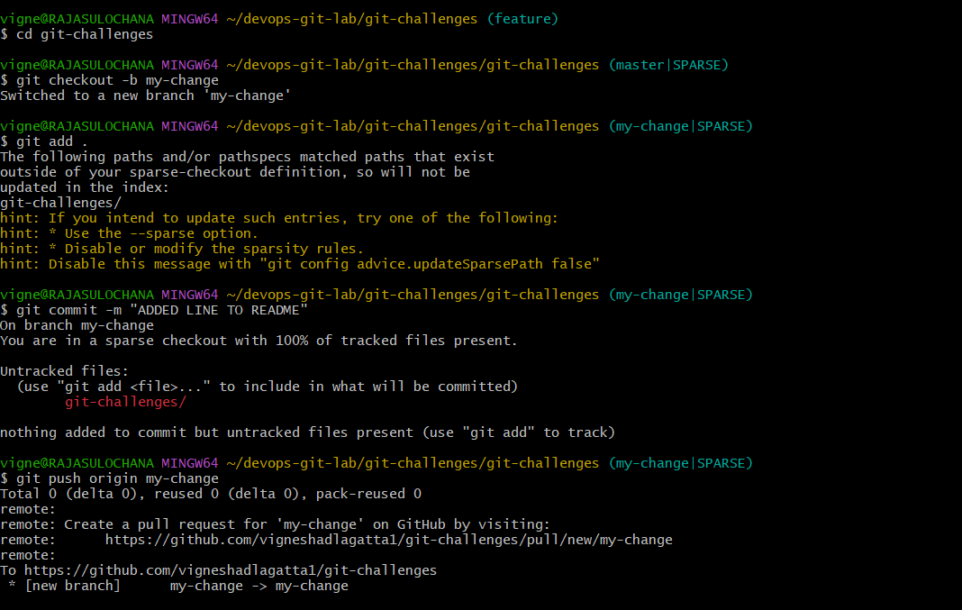

15) Recover Commit After Reset –hard
git reflog
git checkout <lost-commit>
git checkout -b recovered-branch
